PRESS ON MINISTRIES: STUDENT SERVICE LEARNING GUIDELINES

I LIKE COLLEGE STUDENTS VOLUNTEERING AT PRESS ON BECAUSE…..

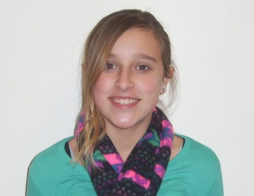
“I like how they interact with us, play
games and help with homework.”
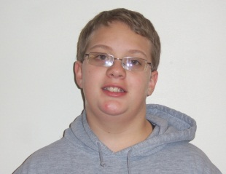
“I like how they interact with us, play games and help with homework.”

“They are nice; they help us and play with us”

604 East 13th Street | P.O. Box 2491
Kearney, NE 68848
308-234-8167
pressonyouthcenter@gmail.com
Look for us on Facebook

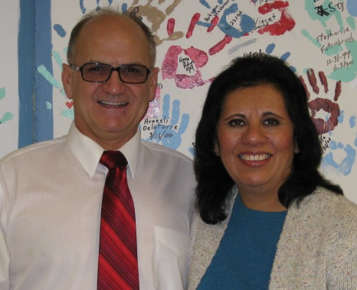
Welcome,
We are very excited that you have been assigned to Press On Ministries, Student Service Learning Program to complete your service learning hours! We opened our doors to student volunteers because we desire to expose students to the value of a Biblical based organization, as well as create a relationship that is mutually beneficial to meeting PressOn’sneeds and building your resume and experience. We look forward to offering you educational experiences and opportunities and we look forward to what you will teach us. Please keep in mind we are here to serve you as well, if you have questions or are interested in any aspect of our operations please feel free to ask. We look forward to seeing you around and helping us help kids on the road of life!

In Christ Love,

Jim & Teri Wilson

PROGRAM SERVICE HOUR REQUIREMENTS
We recognize our student volunteers as responsible adults; as such, we trust that you are honestly and accurately tracking your service learning hours. Regardless of the total number of hours, required by your academic institution, we require you to complete the following as part of our program.
First, you are required to complete a minimum of 2 hours of youth centered service. Service in this area may include interacting with the youth during open recreation, after school tutoring, assisting youth with Mail Box Club lessons, serving as a monitor on the bus, etc.Why do we have this requirement? Since we are a Youth Center and “helping kids on the road of life” is our mission, we believe it is important for you to be involved at the “grass roots” level of our mission. While you may end up serving in a primarily administrative role, we believe this experience will better equip you to succeed. For example, if you are maintaining our website or social media, you will have a better understanding of the photos we provide you thus writing more specific captions, etc.
Second, you are required to spend one service day leading a project or activity in an area related to your major.For example, a physical education major may prepare a group game. An education major may develop worksheets for homework time. A business major may update the photos in our marketing materials or prepare a “pitch” to the directors for a new marketing idea.We ask that you come prepared and provide the Director’s with a copy of your resources one day prior to leading your activity. Alternatively,you may pre-arrange to arrive 30 minutes early the day of your activity;this will ensure enough time for adjustments should they be necessary. We ask for advanced notice of your activity/project for a couple of reasons. First, this review will ensure safety for yourself, Press On and the youth involved. Second,we welcome the opportunity for us to provide you with useful feedback; we feel our knowledge and understanding will benefit your educational experience.
Third, you are required to attend a one and one half hour training on our Philosophy of Ministry. Trainings will be offered at pre-arranged dates and times which will be communicated to you during your tour of the facility; as the days/times may vary each semester. Finally, we ask that this training be completed no later than your third volunteer day.
We understand, as students, you have a busy schedule so outside of these three requirements we will do our best to work with you to complete the remainder of your hours in an area of interest you indicated on your application. We do this in an effort not only to help you complete your class requirement; but also to provide you with the maximum educational experience possible, in an area of your interest, that may benefit your resume and career portfolio. We desire to see you succeed!
SUMMARY
- 2 hours of youth focused service
- 1.5 hour Philosophy of Ministry training
- One service day = project or activity designed and implemented by you
- Completion of remaining hours in an area of interest as indicated on your information sheet. Please note, this is subject to availability.
- Reflection of your time at Press On thru completion of the evaluation form (encouraged)
ATTENDANCE EXPECTATION
Again, we recognize you as a responsible adult and as such we ask that if you are unable to attend a scheduled service day you provide 24 hours advanced notice whenever possible. Please note, attendance does impact our evaluation, of you, as this service is a requirement for your University studies. We understand things happen and will not hold you accountable for a missed day as long as you contact us, in advance, to let us know.
ATTIRE:
Unless your role is administrative, remember to wear clothing you can easily move, play and possibly get dirty in.
RULES SPECIFIC TO PRESS ON MINISTRIES
As a not-for-profit organization in which you will be serving as a role model and representing Press On Ministries to children, parents and the community, the following rules apply:
1. No profanity
2. No smoking
3. No clothing that promotes drugs, violence or inappropriate behavior
4. Do not provide any youthwith transportation home
5. Do not provide money to any youth
6. Youth are instructed not to solicit at Press On Youth Center; as such, please do not purchase from youth
* (i.e. school magazines, Girl Scout Cookies, etc.)
7. Cell phone use should be limited and ring tones should be set to silent or vibrate
8. We ask that your service time be spent serving in your area; therefore, please keep peer to peer game time to a
minimum.
9. If you are ever unsure about something…please ask
TESTOMONIALS:
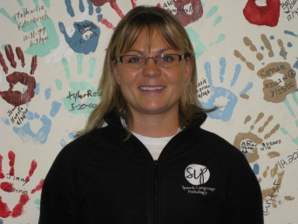
NAME: Kiley
YEAR: Senior
MAJOR: Communication Disorders
Q. What do you feel you gained from your time at Press On Youth Center?
A. “Your philosophy to why you do what you do. That was one of the most meaningful talks I have ever sat through.
Observing and interacting with the youth gave me a much better understanding as to why adolescents act as they do
and what to expect in the future should I have a job working with adolescents. As I have learned, many of my future
clients will be at-risk children; considering your philosophy- the four domains, safety, boundaries, the thought process
and the “why’s,” etc. – I have really considered how I will manage my classes and clients in the future. I have a better
understanding as to how I can facilitate and help children so they are not doing it alone.”

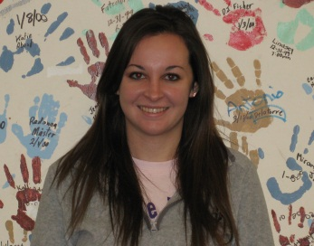
NAME: Kaylene
YEAR: Freshman
Major: 7-12 Mathematics Education
Q. Why did you choose to continue to volunteer at Press On Youth Center?
A. “Because I love the atmosphere, and getting to spend time getting to know and be with the kids.”

